# PULSED POWER PHYSICS TECHNOTE NO. 2020-04

TITLE: LSP SIMULATIONS OF ION DIODES

AUTHOR(S): David Hinshelwood

NRL Code 6770

**DATE:** Feb 26, 2020

**ABSTRACT:**

This note summarizes results of 2D and 3D LSP/Chicago simulations of the Gamble II ion-beam diode. The modeling effort described here is admittedly preliminary and there is a lot of room for improvement. Nonetheless, some interesting results have been obtained.

2D simulations are in general agreement with both analytic theory and experimental results, in regard to diode impedance and ion-current efficiency. They also do a reasonable job of predicting fluence profiles for our standard geometry. They predict that about 3/4 of the ion emitted at the anode exit the diode. This value is not too different from the 2/3 value inferred from experimental data.

These simulations are not able to reproduce experiments with long Kimfol gaps or no Kimfol altogether. Quick attempts to trigger spotty anode emission by introducing nonuniformities in electron or ion emission were also not successful. Possible reasons for both discrepancies, and solutions, are suggested.

In general, simulations show ion emission to be peaked on axis, which agrees with analytic predictions but appears to differ from experimental observations. Simulation results suggest that this discrepancy cannot be resolved by assuming that ions emitting on axis have greatly different trajectories and miss the measurement area (as was suggested in TN2020-02).

We have one crude run where a limited emission of ions seems to lead to radially-flatter emission. But simulations also indicate that if ion emission were really so spotty, the total ion current would be greatly reduced below what we observe.

Suggested refinements to both numerical modeling and experimental diagnostics are suggested.

**Introduction**

This note summarizes results of 2D and 3D LSP/Chicago simulations of the Gamble II ion-beam diode. These have been run intermittently since 2013. The 3D runs were performed around 2013 using a cluster we had at the time. A new arrangement will be needed for any future 3D runs. The 2D runs described here were run recently. Most used LSP 6.86 while a few used Chicago; one LSP run was repeated on Chicago with no discernable difference. The modeling effort described here is admittedly preliminary and there is a lot of room for improvement. Nonetheless, some interesting results have been obtained.

We have been dissatisfied with the uniformity and reproducibility of the ion beam since this effort began around 1980, as has been discussed in numerous prior talks and reports. There are three major problems: (1) the beam shows poor (~2X) shot-to-shot reproducibility, which limits our ability to tune to a desired fluence; (2) the beam is too peaked on axis, which limits our useful exposure area, and makes it harder to estimate the on-axis fluence from peripheral measurements; and (3) the beam is splotchy, which causes the same problems as (2). These problems call for two lines of attack: (1) trying to improve the uniformity and reproducibility of beam generation (nominally by changes to the diode region); and (2) altering the diode and/or transport geometry to produce a flatter and more-paraxial global beam profile. These two complement each other. For example, if the average ion trajectory were paraxial, we could increase the transport distance for a given fluence, hopefully allowing the inherent beam microdivergence to smooth out the beam profile. Alternatively, a more reproducible beam would make it easier to evaluate new geometries.

Pinhole images point to a very splotchy source of ions at the anode, as shown in Fig. 1. We need to be careful here: what the film shows, is that ions that impinge on a given location at the target plane come from a spotty region on the anode. We would need to view an array of images extending over the full beam profile, and sum all exposures, to be able to comment on the actual source uniformity.

Figure 2 shows the first (as far as I know) framing-camera images of the anode. Timings are shown in the associated graph. Operation without Kimfol allowed us to obtain these. The first frame shows evidence of the expected striations in emission from the thin cathode. The second shows the expected pinch on axis. The problem with such imaging is that it is not possible to tell whether the variations in luminosity are indicative of variations in anode-plasma density, or of variations in electron-current density. I suspect the latter, and so these images may not be very useful in diagnosing the anode plasma. The right image comes from the following shot where Kimfol was present and shows (presumably) light from the Kimfol. Again it is not possible to say whether the light is primarily a reflection of heating due to the ion beam or due to return current flowing radially through the foil. At least the pictures are pretty.

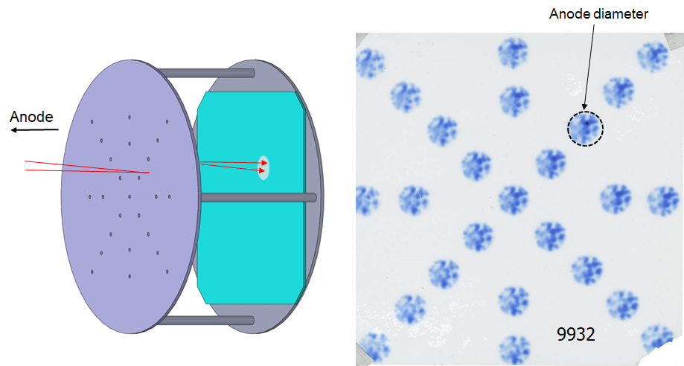

**Fig. 1:** (left) Radiachromic-film diagnostic; (right) Exposed film. (from 2014 ICOPS)

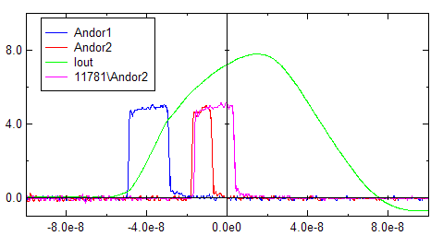

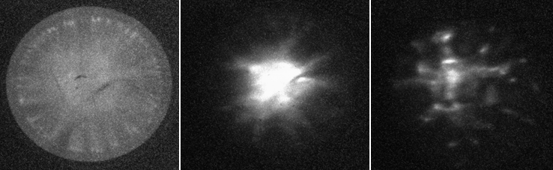

**Fig. 2:** (top) gate times for framing-camera images; (bottom) Images of the anode (no Kimfol was present) at two times, and an image of the Kimfol on a shot where it was present.

To improve the uniformity of beam generation, we need to know to what extent the problem is a nonuniform anode plasma, vs a nonuniform electron flow. Obviously our mitigation strategy would depend on which cause was dominant. Therefore, one goal of modeling is to be able to reproduce (and thus study) this nonuniformity. The second goal is to be able to predict the influence of the diode and transport geometry on beam transport and focusing.

**2D Simulations**

(A representative deck appended to this report.) Figure 4 shows the geometry used in most simulations described in this note. Figure 3 shows the electrical waveforms. In Fig. 4 the green surfaces are aluminum with a 150-kV emission threshold. The radial feed has a very low impedance (both a low geometric impedance and a reduced (0.1) phase velocity) so that the input voltage is clamped. The left graph in Fig. 3 shows the input voltage compared with that between the anode and back foil on the axis. Currents are shown in the right graph. Iin is the input current; Anodeions, Anodeelecs, and Anodetots are highly-smoothed particle currents at the anode; Kimions is a smoothed ion particle current at the back foil. As expected, the particle and electrical currents match, and almost all ions that leave the anode reach the Kimfol (a very small fraction hit the cathode as seen in Fig. 4).

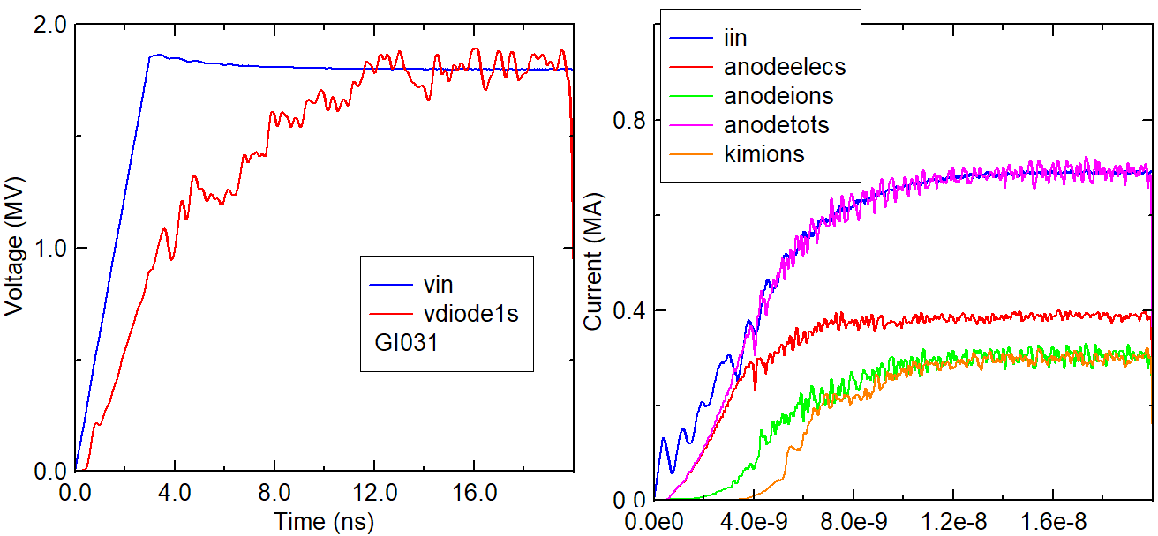

**Fig 3:** (left) Applied and diode voltage; (right) Currents – see text for details.

The pulse length was chosen to be long enough for the ions to reach equilibrium. It is not long enough for equilibrium in some of the extended geometries described later in this note, and this is one area for improvement in the future.

Various particle, rBtheta, and trajectory results are shown in Fig. 4. The geometry is fairly close to that on the experiment, but we could do better, for example including the beveled ring that clamps the anode.

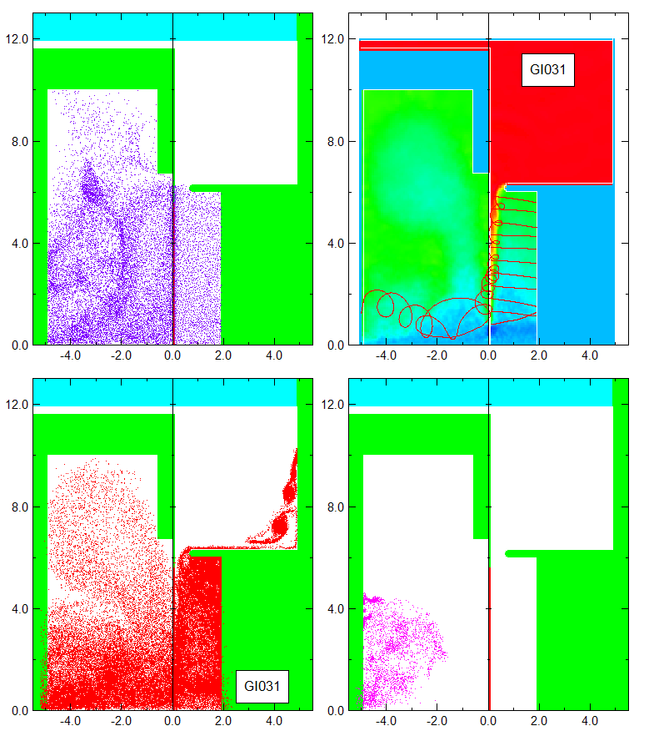

**Fig. 4:** LSP geometry with protons near the end of the pulse at 18 ns (upper left); cathode and Kimfol-emitted electrons at the same time (lower left); Electrons emitted from behind the anode at the same time (lower right); rBtheta contours at 18 ns and trajectories at 15 ns (to give time for ions to cross the gap). The trajectories include a few from electrons and 11 from ions.

The empty region behind the anode is much larger in the experiment. Particle and rBtheta plots from these simulations point to a lot of interesting physics in this region, but in practice we see very similar results when the “backless” anode is replaced by a solid anode. So this physics will not be addressed further here.

There is a known problem with 2D cylindrical geometry when ions are present on the axis. At the suggestion of our theory group, I gave both ions and electrons at 10-kV transverse temperature in the run shown in here, and all other runs unless noted.

Figure 5 compares LSP and experimental electrical data. The input wave was set to match the diode voltage. The two data sets are shown here arbitrarily time-aligned to match total currents, but this is reasonable. The LSP gap was 5.7 mm while the initial gap in the experiment was 8.5 mm. The calculated (based on Paul’s analytic formulae) gap on 11484 is almost exactly 5.7 mm at the center of the LSP pulse. The “experimental” ion current is actually calculated based on Paul’s model but has been benchmarked against measurements in the past. This agrees very well with the LSP prediction. So in summary we see that LSP does a good job of matching our analytical model, as well as (to the degree that we can measure) experimental data.

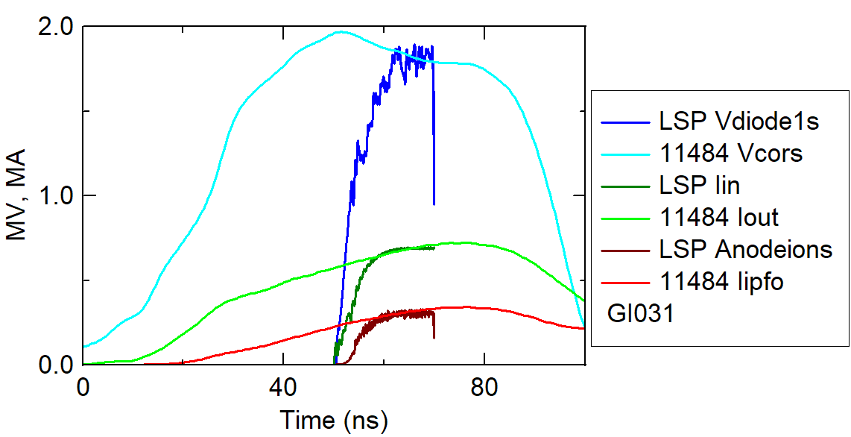

**Fig. 5:** Comparison of diode voltage, total and ion currents with typical experimental traces.

Figure 6 shows angular distributions (weighted by solid angle) at the Kimfol for 5 different radii. Positive angles correspond to outward-moving ions. As expected (and seen in the trajectories in Fig. 4), ions at outer radii have a slight inward movement. The FWHM is about 12 degrees, or 0.2 radians. I believe this is close to the value assumed by Dave Mosher in his modeling. The right graph in Fig. 6 shows corresponding results when no initial transverse temperature is applied. In this case the angular spread is roughly halved.

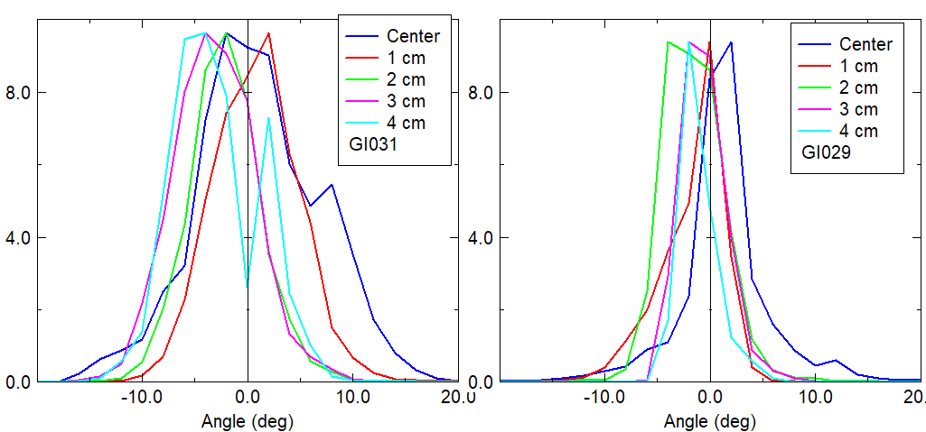

**Fig. 6:** Solid-angle distributions at the Kimfol at different radii. The left graph is from the standard LSP condition with 10-kV thermal energy; the right graph comes from a run with no thermal energy.

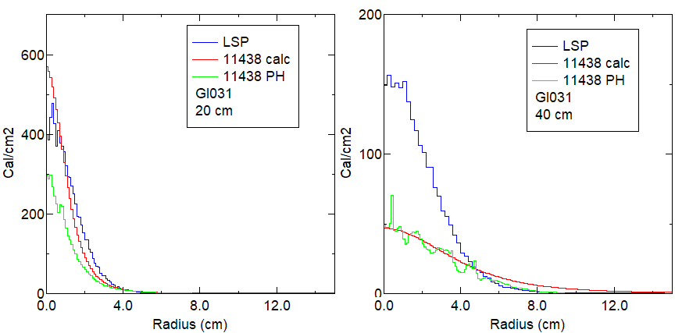

**Fig. 7:** Comparison of projected profiles from LSP (blue) with experimental analytic and projected profiles, at 20 cm (left) and 40 cm (right).

To model transport fully, we need to have the ions pass through the Kimfol unscathed, but also to allow electron emission from the Kimfol. LSP has a limitation that thin foils cannot emit, and finite-thickness foils will stop ions. (I gather from the documentation that there is a way around this, but I haven’t looked further.) In these simulations ions are simply collected at the Kimfol and then transported ballistically in Stella. Obviously this ignores any physics involved with beam neutralization when it exits the Kimfol. Ultimately, ions could be collected and then fed into a subsequent LSP calculation that begins at the Kimfol location.

When transporting, 2 filtering operations with the PartGroup routine are used to remove any ions that would have intercepted the snout on which the Kimfol is mounted (see the drawing in TN 2020-02).

Figure 7 compares ballistic projections to 20 and 40 cm. The experimental curves are described in TN 2020-02. The red curves are from an analytic profile in terms of distance and radius that fits all data reasonably well. The green curves are from measurements with the large diagnostic assembly. As discussed in the Technote, neither is particularly good close to the diode. Here, we see reasonable agreement at the close distance, but LSP predicts a more-focused beam going forward. This may be related to the aforementioned issue with ions on the axis in 2D cylindrical geometry.

All LSP-predicted fluences are shown here multiplied by the ratio of 30 kJ (the nominal ion-beam energy in experiments) to the integrated ion-beam energy in the diode (obtained from VDiode1s and Anodetots) in the simulations. Thus, the comparisons shown in these graphs are nominally in absolute units.

The total energy obtained by radially-integrating the projected distributions is roughly 3/4 of the electrical energy in the diode. As discussed in TN 2020-02, this ratio is about 2/3 in experiments. In the simulations, this energy loss is the result of ions hitting the snout, and (to a lesser extent) ions hitting the cathode. I think this is close enough to the experimental loss to suggest that the loss in total beam energy from the diode to downstream locations can be explained by ions being captured by the diode geometry.

These simulations used cells whose radial dimensions went from 0.5 mm on the axis to 1 mm at the edge, and whose axial dimensions went from 1 mm at the ends to 0.4 mm at the anode foil. One simulation was performed with all dimensions reduced by half. Otherwise, the deck was identical to that for GI031 in Fig. 7. Results are shown in Fig. 8. With the smaller cell size, the discrepancy between LSP and experiment at 40 cm is reduced.

Figures 9 and 10 show results for cases when particles (both electrons and ions) were emitted with no transverse temperature, and when both were emitted with 100-kV transverse temperature. Results here are not surprising: with the former we get an unphysically-narrow beam, and with the latter we get an unphysically-broad beam.

Figure 11 shows calculated ion current densities (time-integrated to give charge densities) at the Kimfol plane for these cases. These are arbitrarily scaled to highlight differences in shape; with 10-kV transverse energy the shape is close to the 1/r distribution that would be expected.

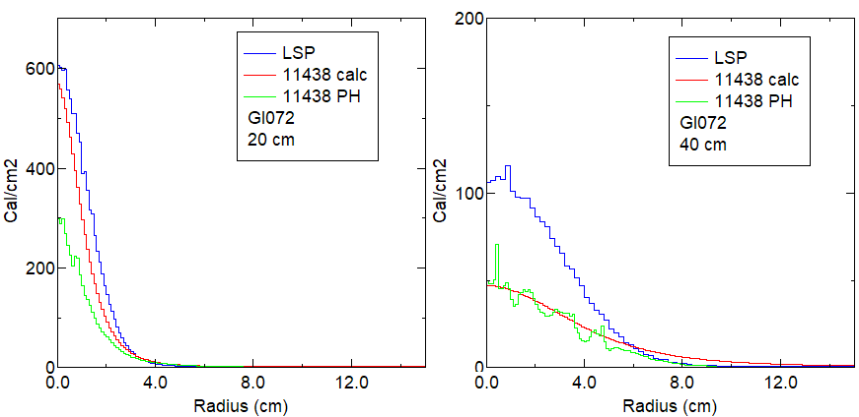

**Fig. 8:** Corresponding results to those in Fig. 7, for a simulation with half the cell size of GI031.

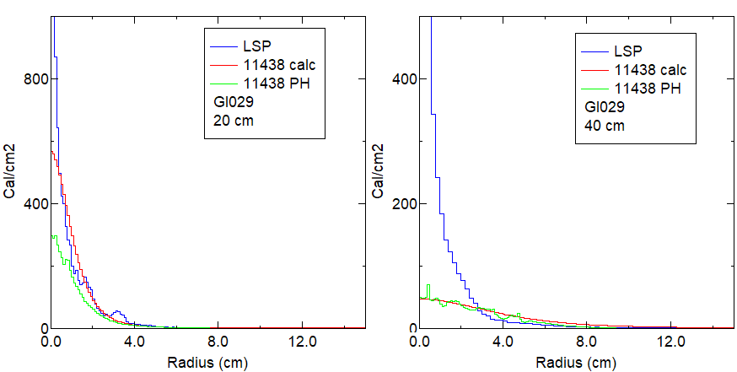

**Fig. 9:** Results for a shot with no transverse temperature for either electrons or ions.

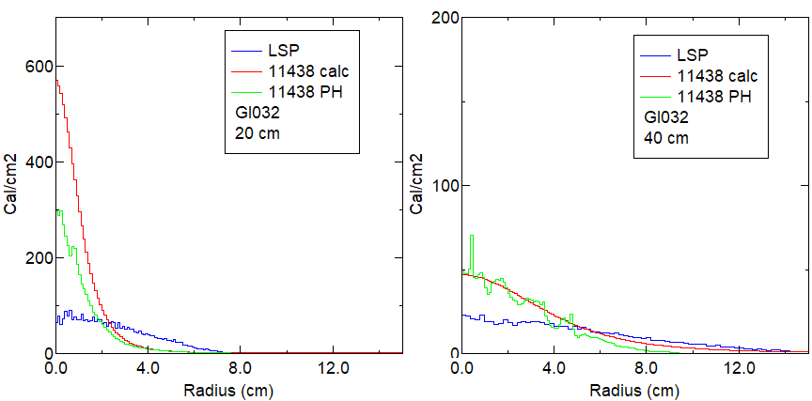

**Fig. 10:** Results from a shot with 100-kV transverse temperature for both electrons and ions.

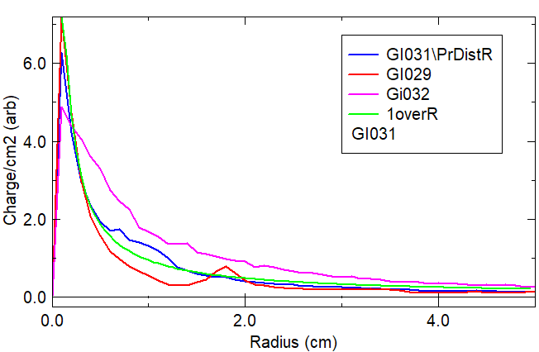

**Fig. 11:** Radial distributions of ion current at the Kimfol plane, compared with a 1/r distribution. Curves are for 10-kV (blue), 0 (red), and 100-kV(green) transverse temperatures.

**3D Simulations**

In 2013 I ran some 3D versions of the simulations described above. Steve Richardson was very helpful in getting me started on the cluster we had at that time. These used Cartesian geometry and modeled one quadrant of the problem. Particle quantities are multiplied by 4 to account for this. The simulations had 4 regions of 20 domains each and took about 14 hours to run (compared to about 40 minutes for the 2D runs). The geometry was identical to that used in 2D. The cells went from 0.5 mm in both the X and Y directions at the axis to 1 mm at 12-cm radius. The axial cell lengths were the same as in the 2D runs. As seen in Fig. 12, the electrical behavior in 3D is virtually identical to that in 3D.

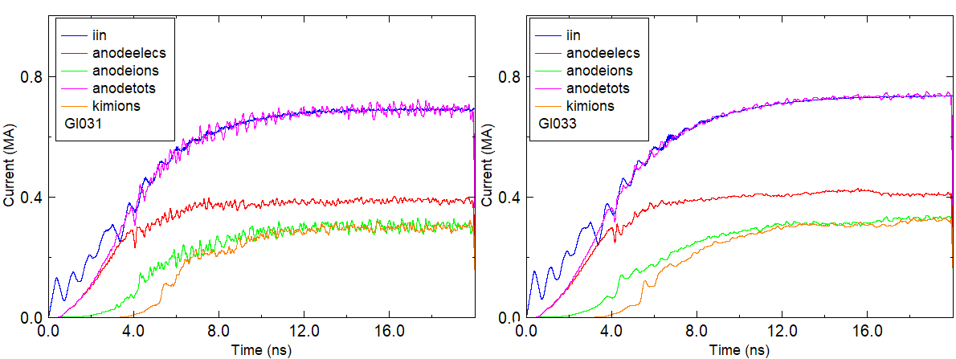

**Fig. 12:** Electrical traces for 2D (left) and 3D (right) simulations of the same geometry

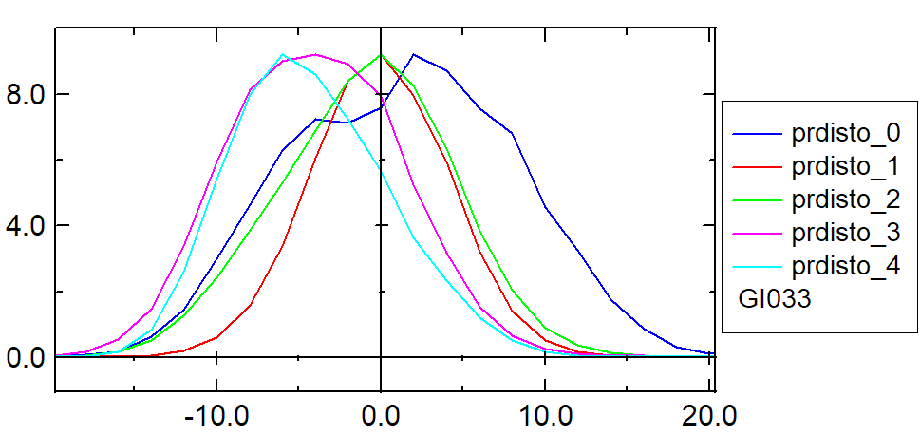

**Fig. 13:** Solid-angle distributions at the Kimfol at different radii for a 3D simulation with 10-kV transverse temperature (compare with the left graph in Fig. 6).

Figure 13 shows angular ion distributions at the Kimfol for a run with 10-kV transverse temperature. These distributions are just a bit wider than those from the corresponding 2D run in the left graph of Fig. 6.

Particle plots are shown in Fig. 14. There are a lot more particles in the 3D case (a function of the much larger number of cells), but the general behavior looks the same as seen in Fig. 4.

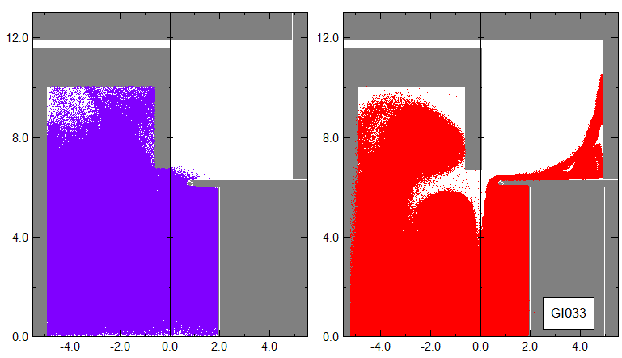

**Fig. 14:** Ion (left) and electron (right) flow near the end of the pulse in the 3D simulation.

Figure 15 shows the radial profile of the time-integrated ion current at the Kimfol for 2D and 3D shots with 10-kV transverse temperature. Results for the two cases are similar.

Figure 16 shows the projection ion-beam-fluence profiles at 20 and 40 cm. These should be compared with those in Fig. 7. The discrepancy between simulation and experiment is reduced in 3D (even more than by going to half-scale cells as shown in Fig. 8).

I had been saying that issues with 2D cylindrical geometry when ions are present necessitated the use of 3D modeling. After looking over these results, it seems that results of 3D runs are indeed closer to the experimental data, but the difference is less than I had thought previously.

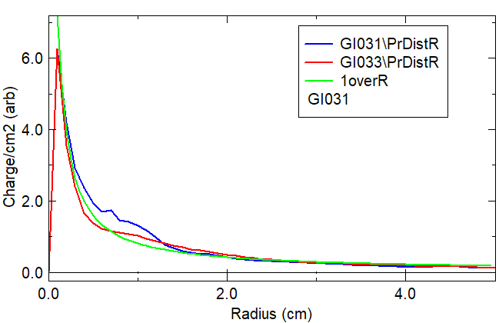

**Fig. 14:** The radial distribution of time-integrated ion current at the Kimfol plane.

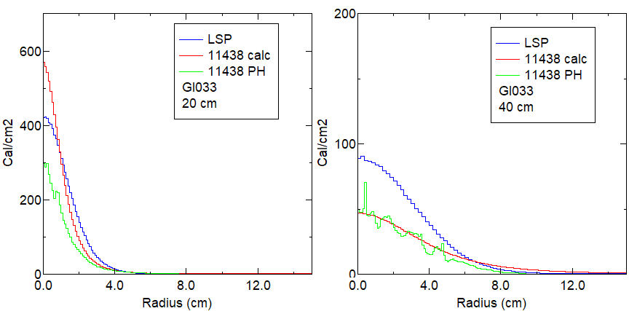

**Fig. 15:** Projection ion distributions for a 3D run; compare this with Fig. 7.

**Effect of geometry variations**

Figure 16 shows projected ion-beam distributions from shots with the large diagnostic array. These are described in more detail in TN 2020-02; the plots shown here are obtained by taking radiachromic-film pinhole-camera images and projecting them back to the anode. The top plot comes from a shot under standard conditions. As discussed in the previous note, the beam comes to a rough focus close to the diode. (The pinhole images suggest that the focus is at about 20 cm, but these do not sample all the beam; extrapolation of fluence profiles suggests that this focus is closer to 12 cm.)

The middle plot comes from a shot where the Kimfol was located on the back of the snout, 12-cm further back than normal. In this case, the beam “focuses” much further out, the fluence profile is more peaked on axis, and the on-axis fluence falls off much more slowly with distance.

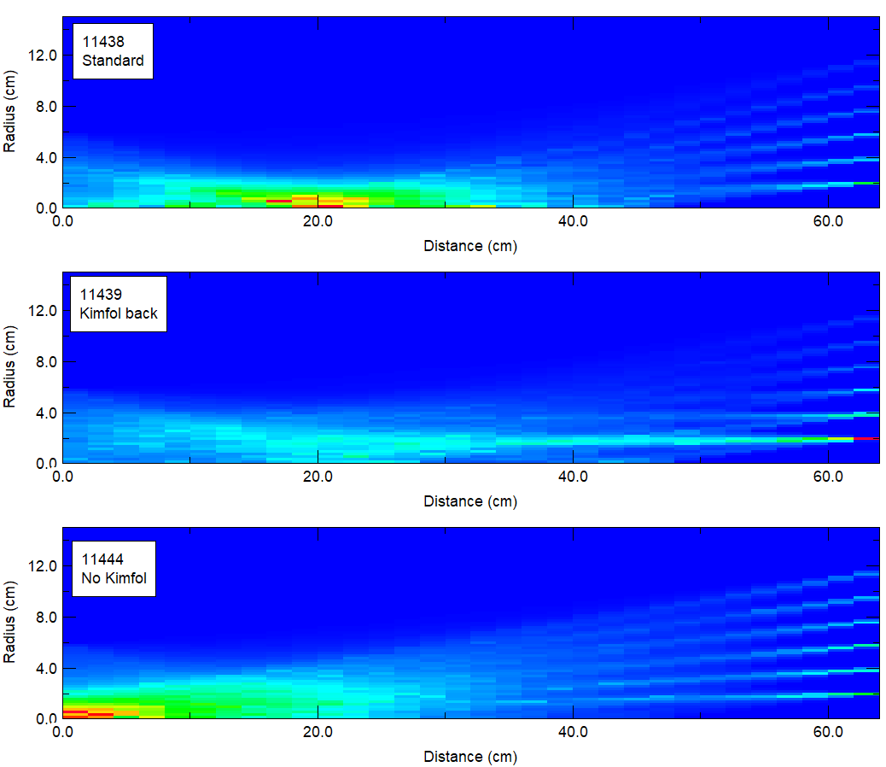

**Fig. 16:** Experimental data from the large diagnostic array (see text for description).

The bottom plot comes from a shot with neither Kimfol nor snout. In this case the beam is seen to diverge from the anode. This arrangement produces a flatter radial profile but with an on-axis fluence that falls off much more quickly with distance.

I made a first attempt to simulate these altered geometries in 3D back in 2013. But those simulations only moved the back plane back by 3 cm. I repeated those in 2D recently but also ran some with much larger axial Kimfol gaps. Since the diagnostics were better than in the earlier runs, and since the 3D results were not hugely different, only 2D results are discussed here.

Figure 17 shows the results of the first group of 2D simulations. The left graph is the normal case GI031. The middle graph comes from a run with the Kimfol moved back 3 cm. The right graph comes from a run with no Kimfol at all, just an outlet boundary on the right edge. As before, there are a few squiggly trajectories for electrons and the others for ions. The middle plot does not look qualitatively different but the right plot shows an ion beam that appears to be pinching from a significant net current.

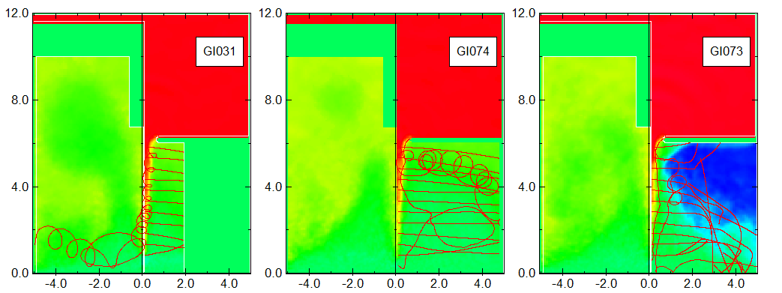

**Fig 17:** rBtheta plots and trajectories for simulations of the arrangements in Fig. 16

LSP predictions are compared with experimental results in Fig. 18. In the experiment, moving the Kimfol back produces a narrower radial profile with a higher central fluence at a given location. Removing the Kimfol has the opposite effect, producing a flatter distribution with a much lower central peak. By contrast, LSP suggests that the central fluence is lower in either case without a significant change in width.

Since these LSP geometries were not reflective of the experiment, the 2D simulations were repeated where the simulation distance was increased by 12 cm rather than 3. Geometries are shown in Fig. 19. For the case with the Kimfol moved back, the geometry reflected the presence of the snout. Figure 20 compares ion currents and projected distributions for these cases along with the standard case.

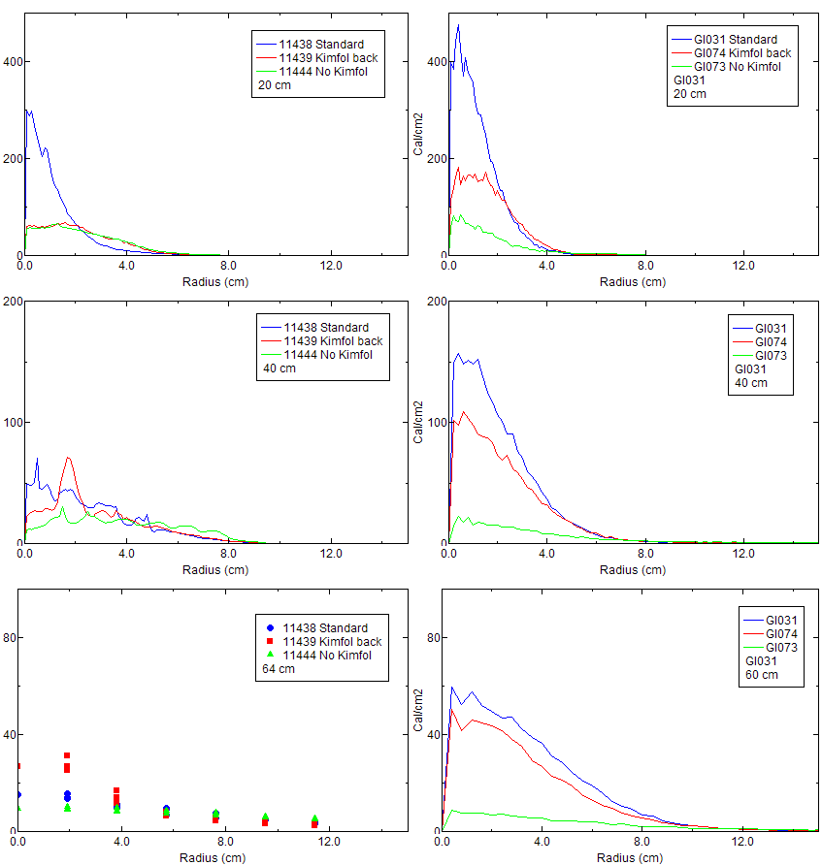

**Fig 18:** Radial fluence distributions from the large diagnostic array (left) and LSP predictions (right). From top to bottom these are at 20, 40, and 60 cm. Direct calorimetry data at 64 cm is shown in the lower-left plot.

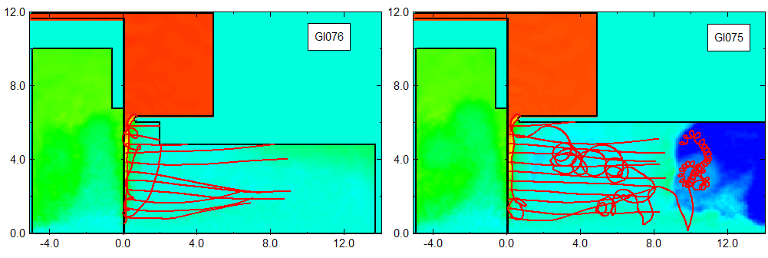

**Fig. 19:** Geometries used in 2D simulations of the more correct extended arrangements. rBtheta plots are shown along with ion trajectories. The right graph is from the run with an open outlet boundary.

The ion trajectories shown began at 15 ns; by the end of the simulation they have not yet reached the back. This is seen more clearly in the left graph of Fig. 20. Because the simulation run time is too short for most of the ions to reach the back, it is difficult to make a quantitative comparison with the standard case. So the projected distributions in the right graph are shown in arbitrary units, scaled to match their peak heights.

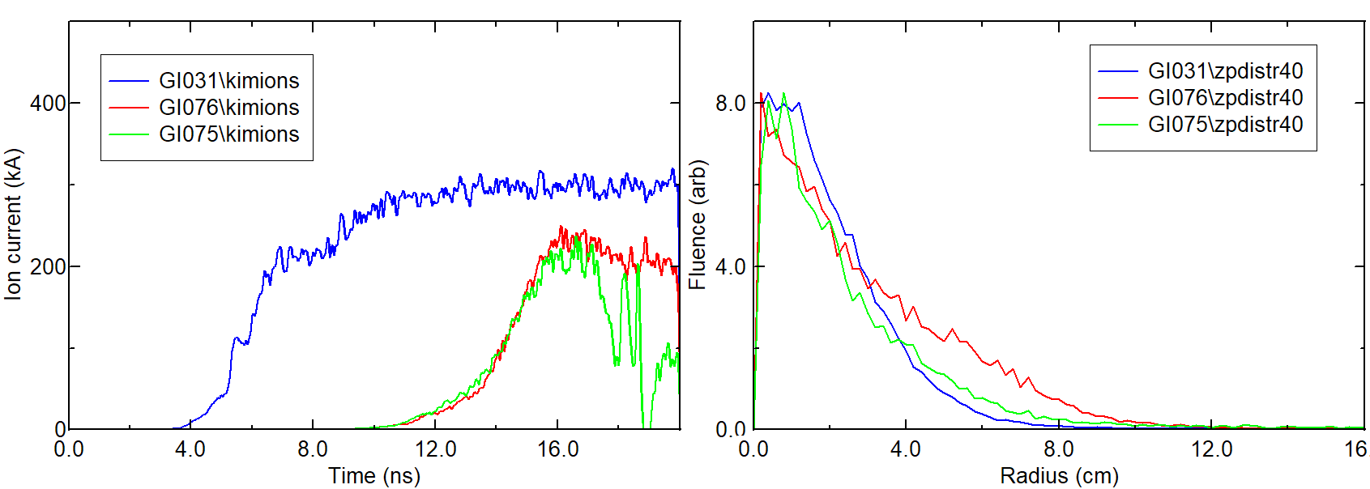

**Fig. 20:** (left) Ion currents at the Kimfol (or back) location for the standard case (blue), Kimfol 12 cm back (red) and without Kimfol (green); (right) Projected distributions at 40 cm.

Note the apparent region of net current in the right graph of Fig. 19. Compared to the shorter simulation in Fig. 17, this region seems to be correlated with the back boundary rather than the diode. Looking at the rBtheta evolution in time shows that this region moves in from the right-hand boundary.

As with the shorter simulations, the profiles in Fig. 20 do not at all match reality.

Clearly, a lot more work is needed to have a chance at simulating geometry variations. Since the ion transit time can be long, we need to model the realistic electrical pulse. Normally this is complicated by the fact that we can’t easily model the time-varying gap. But in this case, the observed insensitivity of the fluence profiles to impedance (that is, high-voltage and low-voltage conditions have the same profiles) may make this problem less serious.

Another thing worth playing with is the emission threshold in the snout. In the experiment, ion bombardment might lead to plasma formation at a lower threshold than in vacuum.

**Attempts to model ion-generation nonuniformity**

One of the motivations for 3D simulations was the hope that we could reproduce (and thus study) the observed spotty nature of ion emission. Results from first attempts are shown in Fig. 21. These are from 3D simulations of the standard geometry, and show the X-Y distribution of fluence at the Kimfol location. All four graphs have the same Z-axis units. The upper-left graph is from the standard-condition run GI033. Both radial and azimuthal modulation can be seen in the distribution. For the upper-right graph, emission at the cathode was turned off over about 3 mm of circumference every cm. This change reduced the total current by only a few percent. This is obviously a crude attempt at mimicking the observed striated emission from the cathode, with a scale length several times too large. This produces more variation in ion emission, but in a regular pattern. The lower-left plot comes from a run where ion emission was limited to a few rectangular regions of the anode. The lower-right graph comes from a run where the anode had several 1-mm-high cylindrical bumps. Interestingly, emission seems to be suppressed at the edges of these. This may be because the anode material in these regions had the same density as the rest of the foil, giving a greater electron stopping power and hence retarding reflexing. I am not sure what is behind the “stripe” at 45 degrees.

I had hoped that we would get lucky and reproduce the observed spottiness by introducing nonuniformity. Admittedly, the above attempts were very crude and this may still be possible with a more careful set of initial conditions.

However, even these crude simulations raise two interesting points. The first is that reducing the ion emission area on the anode reduces the total ion current. This is seen in the left graph of Fig. 23 where the green curve corresponds to the lower-left graph in Fig. 21. This was unexpected, as I had thought that the simple picture of the ion-to-electron current ratio being determined by space-charge balance would force the same total ion current. Evidence of spotty ion emission is seen in experiments: perhaps variations in the ion-emission area are responsible for the observed shot-to-shot variation in fluence at a given location.

The problem with this argument is that when we measured the ion current directly (as was done prior to 2013), we did not see a significant shot-to-shot variation in total ion current.

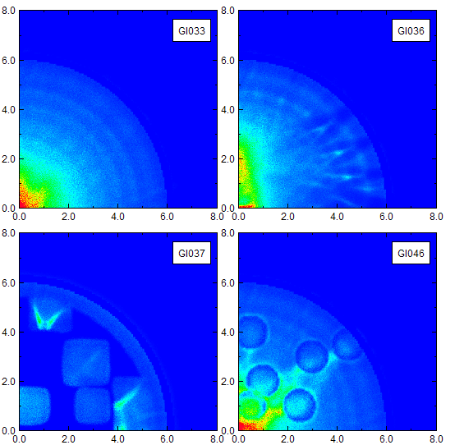

**Fig. 21**: 2D plots of ions at the Kimfol from four 3D simulations: (upper left) standard condition; (upper right) striated cathode emission; (lower left) limited regions of ion emission; (lower right) 1-mm raised regions on the anode.

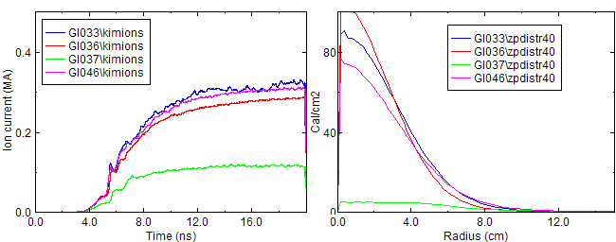

**Fig22:** (left) ion currents for the four shots in Fig. 21; (right) Projected fluence profiles for these shots.

The second interesting feature concerns the radial distribution of ion-beam generation. Results from 2D simulations, all but the lower-left 3D simulation in Fig. 21, as well as simple analytic theory, all indicate that ion-beam generation is strongly peaked on axis. As mentioned earlier, this is expected to be roughly 1/r. On the other hand, pinhole-imaging data points to a spotty but more-radially-uniform source distribution, as seen in Figs. 1 and 24. My first thought was that it was the physics of the backless diode that evened out the distribution, and the region behind the anode was too small in the simulations to reproduce this. But the three film strips on Fig. 23 come from a shot with an old-style, backed diode (5 mm gap between anode and backing carbon, with a plug on axis). These images are virtually identical to those on the right strips, from a shot with a backless diode.

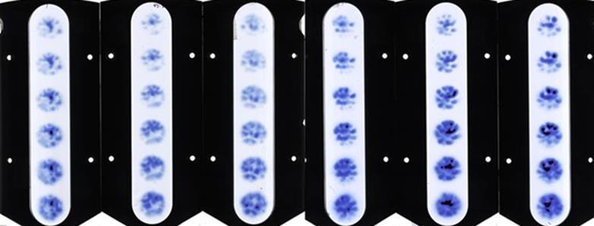

**Fig. 23:** Radiachromic films from backed-anode shot 11912 (left) and backless-anode shot 11913 (right).

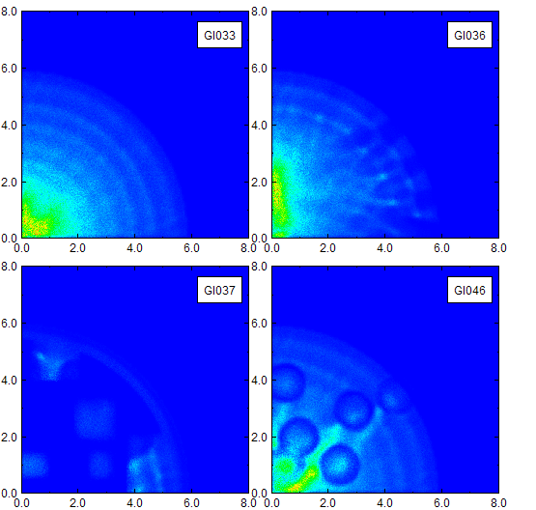

**Fig. 24:** The same distributions as Fig. 21, but now filtered to show only ions that would impact the target assembly.

In TN2020-02, I suggested that the apparent discrepancy was because we only diagnose ions in a forward cone. As mentioned before, the film images do not indicate the spatial pattern of total ion emission, but only emission of ions that travel to the pinhole in question. I had surmised that if we recorded all ions we might see more peaking on axis at the anode. In other words, perhaps ions generated on the axis leave the diode with large angles.

It is also possible that local pinhole images are confusing us about the ion-source uniformity. Perhaps if we fielded an array of pinholes that intercepted the entire beam, and summed their images, we might find that ions are generated over the full anode area. One could imagine a situation where ions are emitted uniformly at the anode but somehow (perhaps during their neutralization at the Kimfol) they get diverted into small beamlets moving in different directions.

We can test this in future experiments by building a larger diagnostic array. In the meantime, this idea was explored in the simulations by filtering the distributions in Fig. 21 so that they only contain ions that would fall within a 5-cm-diam circle at 40 cm distance. These are shown in Fig. 24. They look very similar to those in Fig. 21, suggesting that ions in the forward cone are representative of all ions emitted.

This is shown more quantitatively in Fig. 25, taken from the 3D simulation of the standard geometry. The left graph shows the 2D (radial/angular) distribution of ions at the Kimfol. Ions emitted at the center do have larger angles, but this has a small effect as seen in the right graph. This compares projected fluence distributions at 40 cm for all ions, those that are within 1-cm radius at the Kimfol, and those outside this radius. The central ions have an only slightly wider distribution.

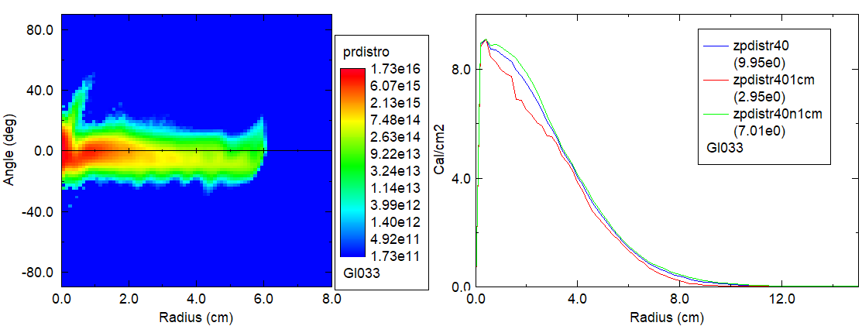

**Fig. 25:** (left) Angular distribution of ions at the Kimfol location as a function of radius, shown on a log scale for clarity; (right) Normalized projected fluence distributions at 40 cm for all ions (blue), and those within (red) and without (green) 1 cm radius

However, the distributions at the lower-left of Figs. 21 and 24, arising from a run with limited anode emission, differ from all the others in that the intensity of ion emission does not appear to be peaked on axis. I am not sure what is going on here but this looks worth exploring further. One possible explanation would be that with spotty ion emission, the electron orbits are altered to produce multiple pinches. I did not record the spatial dependence of electron incidence on the anode in these simulations, but this would be worth doing in the future. On the other hand, we have a handful of shots from the 2011-12 timeframe where the anode was backed with aluminum foil. There is no sign that the affected diode behavior, but it did produce enough x-rays to get a pinhole-camera image. Images on these shots show the expected pinch on axis, even as radiachromic film shows the usual spotty emission.

**Summary of LSP results**

2D simulations are in general agreement with both analytic theory and experimental results, in regard to diode impedance and ion-current efficiency. They also do a reasonable job of predicting fluence profiles for our standard geometry. They predict that about 3/4 of the ion emitted at the anode exit the diode. This value is not too different from the 2/3 value inferred from experimental data.

These simulations are not at all able to reproduce experiments with long Kimfol gaps or no Kimfol altogether. This might be explained by transit-time limitations in these short runs, and/or incorrect treatment of electron emission along the extended structure.

Quick attempts to trigger spotty anode emission by introducing nonuniformities in electron or ion emission were not successful, but there is a lot of room to improve these.

With one exception, simulations show ion emission to be peaked on axis, which agrees with analytic predictions but appears to differ from experimental observations. Simulation results suggest that this discrepancy cannot be resolved by assuming that ions emitting on axis have greatly different trajectories and miss the measurement area (as was suggested in TN2020-02).

We have one crude run where a limited emission of ions seems to lead to radially-flatter emission. But simulations also indicate that if ion emission were really so spotty, the total ion current would be greatly reduced below what we observe.

**Future work**

These preliminary simulations point to both further modeling and experimental measurement.

Subsequent modeling calls for the usual refinements: more accurate geometry, more attention to cell sizes and emission thresholds, more diagnostics (particularly of electron flow), longer simulations using the full electrical pulse. Supposedly, electrode plasma motion can be modeled to some extent. If we had a dedicated modeling effort (for example, with a grad student) this would be an excellent topic to pursue and would be relevant to modeling of all diodes. The simulations here do not model charge and current neutralization of the ions after passing through the Kimfol. This is because the Kimfol has to be both an emitter and be transparent to ions. I did not think that any of the medium models in LSP could do both of these, but the Chicago documentation suggests that this may be possible. Alternatively, ions impinging on the Kimfol could be collected and then used as in input to subsequent runs that begin at the Kimfol.

Both the experimental results described in TN2020-02 and the modeling results described here argue for a total beam measurement: essentially a larger-diameter version of the large diagnostic array that can diagnose all ions emitted from the cathode. We might want to alter the diode geometry somewhat to allow more ions to escape. If we could verify that a thin aluminum foil behind the anode does not alter diode behavior, we could also field an x-ray pinhole camera to get information on electron flow.

**Krasik’s Conundrum**

Back in the last century I had told Yasha Krasik about POS diagnostics I had planned. His reply was that no matter what we learned, what could we possibly imaging doing to improve switch operation that had not already been tried, either in the US or USSR? I had no answer and our program soon went down in flames.

With this in mind, my sense is that we have looked at a lot of small variations with little effect. We are studying transport right now with as-yet unknown prospects. Trying to improve ion-emission uniformity is an obvious avenue to pursue. Using an external circuit to drive current quickly through a foil (the star-crossed EMFAPS scheme) is a very difficult engineering problem. Using a circuit to drive current slowly through a metallic film (Bruce’s heated-anode scheme) involves hardware that would produce unacceptable debris. In view of this, I would recommend that we go long and consider plasma anodes.

**Appendix – Typical LSP deck**

This is for the standard 3D simulation GI033. The standard 2D simulation GI031 is identical to this except for the grid/region section, and with added trajectories.

;GLSP version 6.86 : GLSP_100422

;(06/05/2011 00:00:52)

[Control]

;Time-advance

courant_multiplier 0.9

time_limit_ns 20.0

;Restarts

dump_restart_flag ON

maximum_restart_dump_time 5

rename_restart_flag OFF

restart_interval_ns 5

;Parallel Processing

balance_interval_ns 2

region_balance_flag ON

initial_balance_flag ON

;Field Solution and Modification

time_bias_coefficient 0.25

time_bias_iterations 3

;(Diagnostic Output) Flags

dump_bfield_flag OFF

dump_charge_density_flag OFF

dump_current_density_flag OFF

dump_number_densities_flag ON

dump_surface_depositions_flag OFF

dump_energy_deposition_flag OFF

dump_rho_background_flag OFF

dump_velocities_flag OFF

extract_photons_flag OFF

extract_primaries_flag OFF

;(Diagnostic Output) Dump Intervals

dump_interval_ns 2

probe_interval 1

;(Diagnostic Output) Formats

primary_output_format BINARY

;Numerical Checks and Reports

domain_boundary_check ON

particle_cyclotron_check OFF

particle_motion_check ON

print_convergence_flag OFF

print_grid_flag OFF

;

[Grid]

;

grid1 ; grid 1

xmin 0.0

xmax 12

x-cells 160

x-intervals

dx-start 0.05

length 12 for 160 ;goes to .1 mm

end

;

ymin 0

ymax 12

y-cells 160

y-intervals

dy-start 0.05

length 12 for 160 ;goes to .1 mm

end

;

zmin -5

zmax 5

z-cells 160

z-intervals

dz-start 0.1

length 4.2 for 60 ;to .4 mm

length 1.6 for 40

length 4.2 for 60

end

;

;

[Regions]

;

region1 ; region 1

;

grid 1

xmin 0.0

xmax 1.0

ymin 0

ymax 12

zmin -5

zmax 5

number_of_domains 20

split_direction ZSPLIT

number_of_cells AUTO

;

region2;

;

grid 1

xmin 1.0

xmax 3.0

ymin 0

ymax 12

zmin -5

zmax 5

number_of_domains 20

split_direction ZSPLIT

number_of_cells AUTO

;

region3;

;

grid 1

xmin 3.0

xmax 6.0

ymin 0

ymax 12

zmin -5

zmax 5

number_of_domains 20

split_direction ZSPLIT

number_of_cells AUTO

;

region4;

;

grid 1

xmin 6.0

xmax 12.0

ymin 0

ymax 12

zmin -5

zmax 5

number_of_domains 20

split_direction ZSPLIT

number_of_cells AUTO

;

;

[Objects]

;

;------------------Line

;

object1 CYLINDER ; outer conductor

conductor on medium 0 potential 1

base 0.0 0.0 -6.0

polar_angle Z 0.0

azimuthal_angle X 0.0

height 10.9

radius 30

start_angle 0

sweep_angle 360

;

object2 CYLINDER ; back plate

conductor on medium 1 potential 1

base 0.0 0.0 4.9

polar_angle Z 0.0

azimuthal_angle X 0.0

height 1

radius 30

start_angle 0

sweep_angle 360

;

object3 CYLINDER ; vacuum

conductor off medium 0 potential 0

base 0.0 0.0 -6.0

polar_angle Z 0.0

azimuthal_angle X 0.0

height 10.9

radius 11.9

start_angle 0

sweep_angle 360

;

object4 CYLINDER ; cathode

conductor on medium 1 potential 1

base 0.0 0.0 0.8

polar_angle Z 0.0

azimuthal_angle X 0.0

height 5.0

radius 6.3

start_angle 0

sweep_angle 360

;

object5 TORUS; Cathode tip, 5.7-mm gap*************

conductor on medium 1 potential 1

center 0 0 0.8

polar_angle Z 0 azimuthal_angle X 0.0

major_radius 6.15

minor_radius 0.15

start_angle 0.0 sweep_angle 360

;

object6 CYLINDER ; inside of cathode, 1.92-cm Kimfol gap

conductor off medium 0 potential 0

base 0.0 0.0 0.7

polar_angle Z 0.0

azimuthal_angle X 0.0

height 1.2

radius 6.0

start_angle 0

sweep_angle 360

;

object7 CYLINDER ; Kimfol

conductor on medium 1 potential 1

base 0.0 0.0 2.00

polar_angle Z 0.0

azimuthal_angle X 0.0

height 3.0

radius 6.0

start_angle 0

sweep_angle 360

;

object8 CYLINDER ; anode hub - anode starts at .08 cm**********

conductor on medium 1 potential 2

base 0.0 0.0 -6.0

polar_angle Z 0.0

azimuthal_angle X 0.0

height 6.08

radius 11.6

start_angle 0

sweep_angle 360

;

object9 CYLINDER ; anode interior

conductor off medium 0 potential 0

base 0.0 0.0 -4.9

polar_angle Z 0.0

azimuthal_angle X 0.0

height 4.3

radius 10

start_angle 0

sweep_angle 360

;

object10 CYLINDER ; interior behind thin anode

conductor off medium 0 potential 0

base 0.0 0.0 -0.6

polar_angle Z 0.0

azimuthal_angle X 0.0

height .64

radius 6.7

start_angle 0

sweep_angle 360

;

object11 CYLINDER ; thin anode ring

conductor on medium 1 potential 2

base 0.0 0.0 .04

polar_angle Z 0.0

azimuthal_angle X 0.0

height .04

radius 6.7

start_angle 0

sweep_angle 360

;

object12 CYLINDER ; foil

conductor on medium 2 potential 2

base 0.0 0.0 .04

polar_angle Z 0.0

azimuthal_angle X 0.0

height .04

radius 5.6

start_angle 0

sweep_angle 360

;

[MediumModels]

;

medium1 ; aluminum

method 4

type DENSE

dielectric_constant 1.0

surface_conductivity 0.0

permeability 0.0

temperature 300.0

xgen_data_file xgenAl

electron_cutoff_energy 1.0E+003

photon_cutoff_energy 1.0E+004

electron_transport_flag 1

photon_probability_factor 10.0

diagnostic_flag 0

components

aluminum fraction 1.0

end

extract_photons_flag off

extract_primaries_flag off

energy_units EV;

;

medium2 ; Poly_lite

method 4

type DENSE

dielectric_constant 1.0

surface_conductivity 0.0

permeability 1.0

temperature 300.0

xgen_data_file xgenPoly_0p01

electron_cutoff_energy 0.0

photon_cutoff_energy 0.0

electron_transport_flag 1

photon_probability_factor 10.0

diagnostic_flag 0

components

kapton fraction 1.0

end

extract_photons_flag off

extract_primaries_flag off

extract_secondaries_flag off

energy_units EV

;

medium3 ; aluminum at 1/3 den

method 4

type DENSE

dielectric_constant 1.0

surface_conductivity 0.0

permeability 0.0

temperature 300.0

xgen_data_file xgenAl_0p33

electron_cutoff_energy 1.0E+003

photon_cutoff_energy 1.0E+004

electron_transport_flag 1

photon_probability_factor 10.0

diagnostic_flag 0

components

aluminum fraction 1.0

end

extract_photons_flag off

extract_primaries_flag off

energy_units EV

;

;

[Boundaries]

;

outlet ;

from 0 0 -5

to 11.9 11.9 -5

phase_velocity 0.1

drive_model POTENTIAL

potentials

1 0

2 1

end

circuit 0

temporal_function 1

time_delay 0.0

;

symmetry ; symm1

from 0 0 -5

to 12 0 5

;

symmetry ; symm2

from 0 0 -5

to 0 12 5

;

[Particle Species]

species1 ; electrons

charge -1

mass 1.0

migrant_species_flag off

implicit_species_flag off

particle_motion_flag on

particle_forces_option AVERAGED

transverse_weighting_flag on

particle_kinematics_option STANDARD

scattering_flag on

selection_ratio 1.0

;

species2 ; diode electrons

charge -1

mass 1.0

migrant_species_flag off

implicit_species_flag off

particle_motion_flag on

particle_forces_option AVERAGED

transverse_weighting_flag on

particle_kinematics_option STANDARD

scattering_flag on

selection_ratio 1.0

;

species3 ; protons

charge 1.0

mass 1.836E+003

atomic_number 1

migrant_species_flag off

implicit_species_flag off

particle_motion_flag on

particle_forces_option AVERAGED

transverse_weighting_flag on

particle_kinematics_option STANDARD

scattering_flag on

selection_ratio 1.0

;

;

[Particle Creation]

;

emission child-langmuir field-stress ; emission inside anode

from 0 0.0 -5.0

to 12 12 0.0

interval 1

species 1

discrete_numbers 1 1 1

random on

medium 1

inclusion SOLID

threshold 150

breakdown_function 0

charge_factor 1.0

surface_factor 0.66667

thermal_energy 10000

minimum_charge 0.0

;

emission child-langmuir field-stress ; Kimfol and back plate

from 0 0.0 1.5

to 12 12 5

interval 1

species 2

discrete_numbers 1 1 1

random on

medium 1

inclusion SOLID

threshold 150

breakdown_function 0

charge_factor 1.0

surface_factor 0.66667

thermal_energy 10000

minimum_charge 0.0

;

emission child-langmuir field-stress ; cathode and foil

from 0 0 0.55

to 11 11 1.5

interval 1

species 2

discrete_numbers 1 1 1

random on

medium 1

inclusion SOLID

threshold 150

breakdown_function 0

charge_factor 1.0

surface_factor 0.66667

thermal_energy 10000

minimum_charge 0.0

;

emission child-langmuir thermal ; CH2 born protons *****************change with gap

from 0.0 0.0 0

to 5.6 5.6 0.2

interval 50

species 3

movie_tag 3

discrete_numbers 1 1 1

random on

medium 2

inclusion SOLID

breakdown_function 0

charge_factor 1.0

surface_factor 0.66667

thermal_energy 10000

minimum_charge 0.0

movie_fraction 1

;

emission child-langmuir thermal ; thin-Al-born protons

from 0 0.0 0.0

to 7.0 7.0 0.2

interval 50

species 3

movie_tag 3

discrete_numbers 1 1 1

random on

medium 1

inclusion SOLID

threshold 400

breakdown_function 0

charge_factor 1.0

surface_factor 0.66667

thermal_energy 10000

minimum_charge 0.0

movie_fraction 1

;

[Particle Extraction]

extract1 ;ions on kimfol

species 3

direction Z

maximum_number 10000000

start_time 0.0

stop_time 30.0

at 0.0 0.0 1.9

;

extract2 ;ions at anode

species 3

direction Z

maximum_number 10000000

start_time 0.0

stop_time 30.0

at 0.0 0.0 0.12

;

extract3 ;ions at cathode

species 3

direction Z

maximum_number 10000000

start_time 0.0

stop_time 30.0

at 0.0 0.0 0.8

;

[Functions]

;

function1 ; simple ramp

type 0

data_pairs

-20.0 0.0

0.0 0.0

3.0 950.0

30.0 950.0

end

;

[Probes];

;

probe1

label "Vin"

voltage

from 11 0.0 -5

to 12 0.0 -5

;

probe2

label "Iin"

current

potential 1

from 0 0 -4.9

to 11.9 11.9 -4.9

;

probe3 ;

label "AnodeElec electrons at anode foil"

particle dqdt species 2 direction Z

at 0.0 0.0 0.12

;

probe4 ;

label "AnodeIon ions at anode foil"

particle dqdt species 3 direction Z

at 0.0 0.0 0.12

;

probe5

label "KimElec electrons at tophat"

particle dqdt species 2 direction Z

at 0.0 0.0 1.9

;

probe6;

label "KimIon ions at tophat"

particle dqdt species 3 direction Z

at 0.0 0.0 1.9